IAM TASK
- Create one IAM user and assign EC2 and S3 full access roles
- Search IAM
- Click Create user
- Enter username → example: dev-user
- Click Next
- Choose Attach policies directly
- Search and select these two policies:
- AmazonEC2FullAccess
- AmazonS3FullAccess
- Click Next
- Click Create user
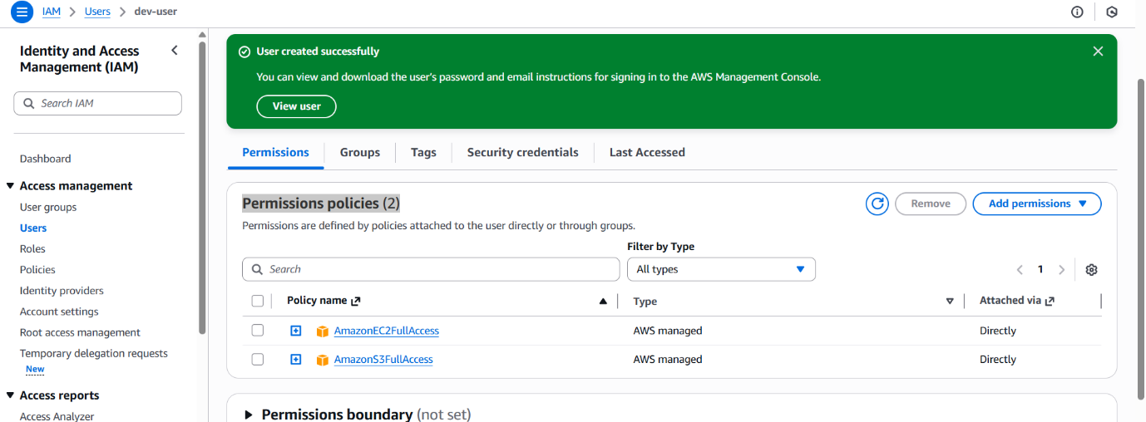

- Create one group in IAM and assign read access for EC2
- IAM On the left side, click User groups
- Click Create group.
- Enter a group name — example: EC2-ReadOnly-Group.
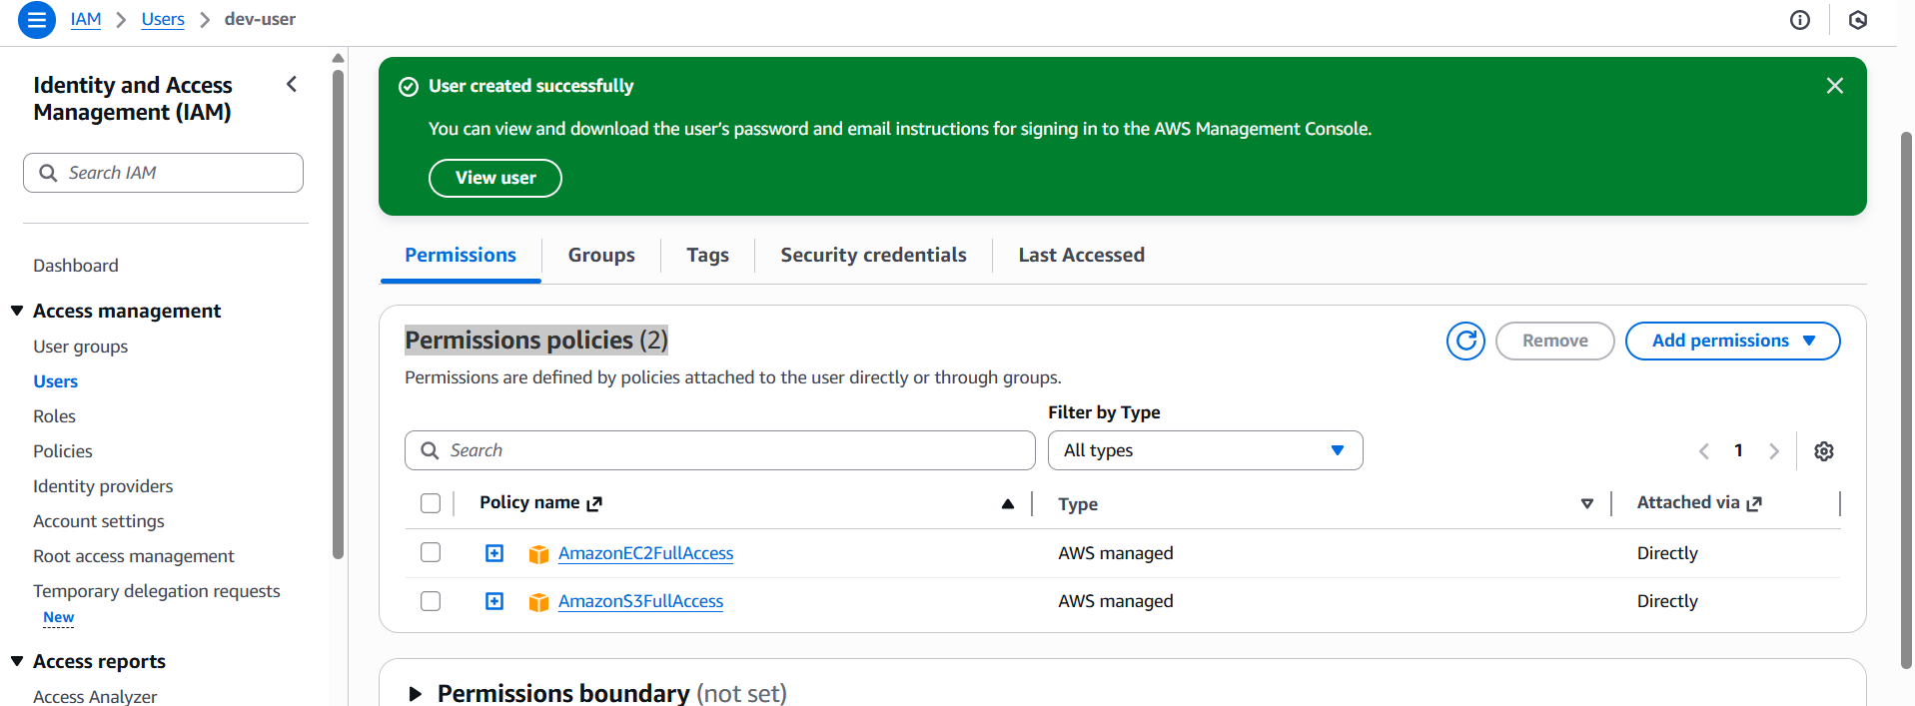
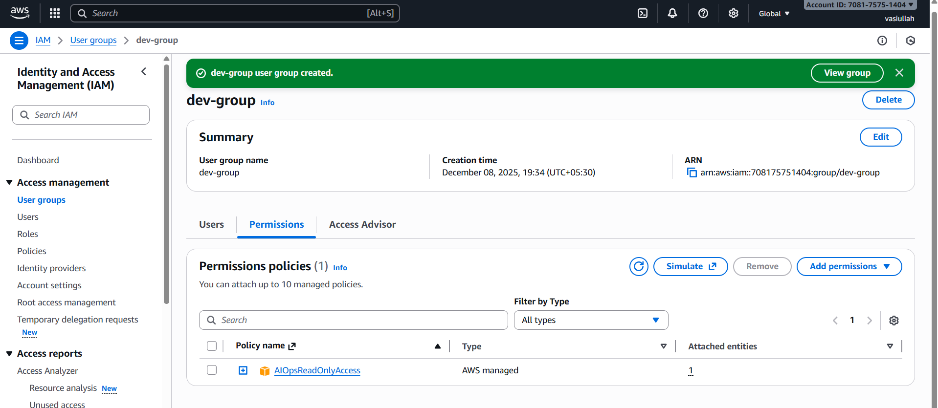
3. Create a new user named "Devops" and add to the group created in task 2.
- Go to IAM → Users
- Click Create user
- Enter username:Dev-user
- Click Next
- Add User to Group
- ec2-read-group
- Click Next → Create user.
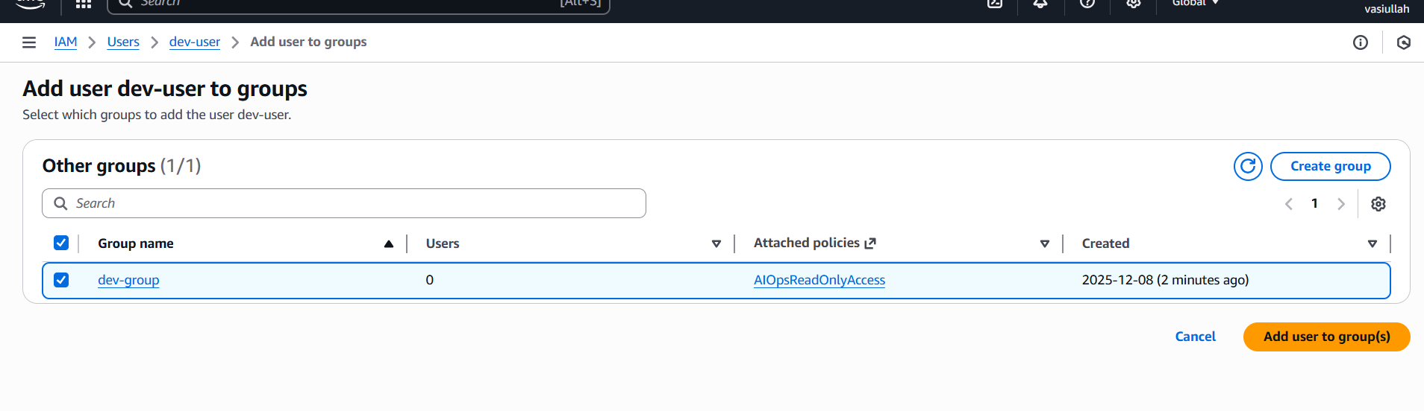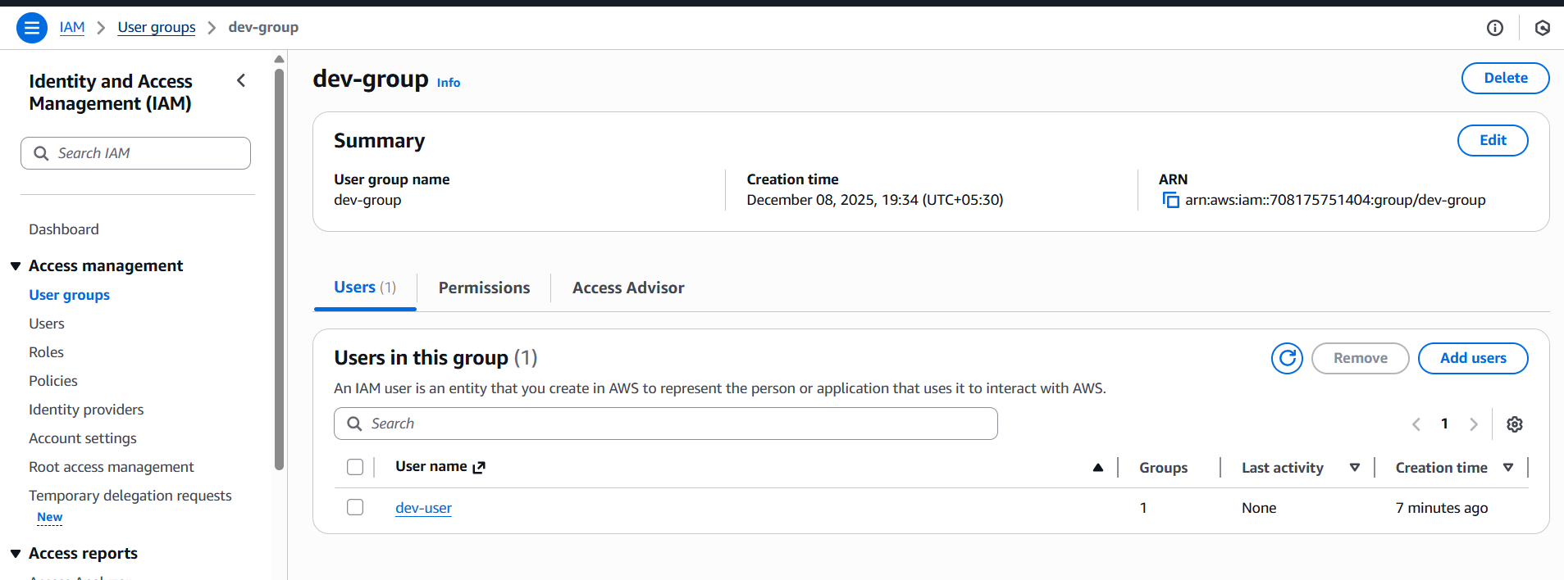
4 .Write a bash script to create an IAM user with VPC full access.
- Go to Aws console
Connect to the instance by using “ssh”
Generate Access key which will find in security credentials
- Aws --version
- Aws configure
- (details )
- Vi create - create-useraccess.bash
- (script paste)
- Chmod 755 create-useraccess.bash
- ./create- create-useraccess.bash

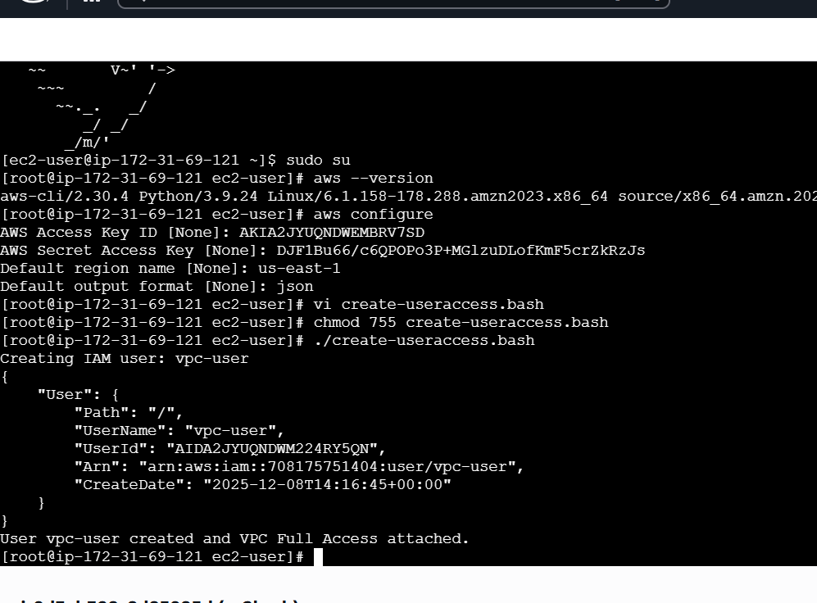
5. Create an IAM policy to allow EC2 access for a specific user in specific regions only.
- Allow a specific user to use EC2
- AWS Console → IAM → Policies → Create policy
- Choose JSON tab
- Example: EC2-Region
- Policies create successfully

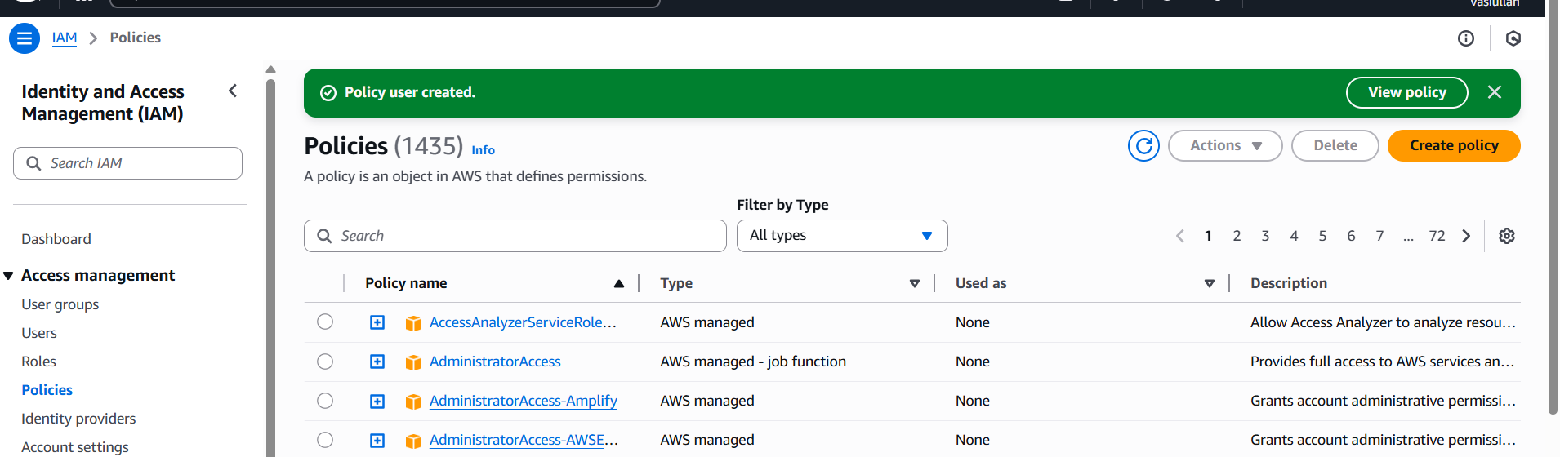
6. We have two accounts: Account A and Account B. Account A user should access an S3 bucket in Account B.
- Sign in to AWS Account A
- Go to IAM → Users → [Your User]
- Copy the ARN. It will look like this
- Add a Bucket Policy in Account B
- Go to S3 → Bucket → Permissions → Bucket Policy
- Replace ACCOUNT_A_ID
- Replace USERNAME
- Replace bucket name
- Attach IAM Policy in Account A to allow S3 actions
